Operations terms results
+ addition addends sum ∑ – summation sign
- subtraction difference
× multiplication factors Π – multiplication sign
÷ division quotion

1/9 – fraction: numerator/[fraction bar]/denominator
3/9 → 1/3 – reduction
ax/ay --> x/y – cancelation

21/126 – [cislo] over [cislo]

2³ – two cubed, two to the powah of 3
-to raise to the power
6.022×10²³ – multiplied by ten to the power of 23rd power
...×10⁻³⁴ – to the negative power of 34

odmocnina – square root of [number]; operation: extraction the root

a → 1/a – reciprocal value of a

to round up/down – zaokrouhlit
(to the nearest tenth, nearest hundredth, ...)

0.2346 – four significant figure
0.002346 – -||- (leading zeros don't count)
0.2346000 – eight significant figures

trailing zeros – 0.2000 – specify accuracy of balance (váhy)

types of numbers
cardinal – how many (seven)
nominal – order (seventh)
ordinal – code (ID number, postal code, ...)

Graphs
t (min) 1 2 3 4 5 6 7
s (m) 100 200 300 390 450 500 520

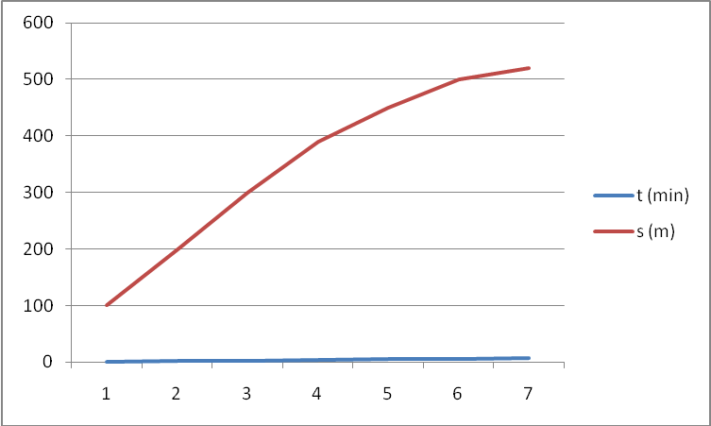
axis – osa (pl. axes)
horizontal axis (abscissa)
vertical axis (ordinate)
dependent variable / independent var
to be plotted – být vynášen (na osu)
scale – měřítko
markers – the stuff on the graf (body)
line of best fit – spojnice

závorky
parenthesis: ( )
brackets: [ ]
braces: { }

elderflower – černý bez
mulled wine – svařák

2010-09-10
sector – kruhova vyseč

gut:
gutted – vykuchat, dissapoint (eviscerate –to remove internal organs of a fish,..)
loose the gut – zhubnout (abdomenalni tuk)
guttless (has no guts)
gut feeling – i know i'm right but dunno why

2010-09-17
Waves
-are vibrations which transfer the energy from place to place
-they do this w/o transferring of matter particles (applies to waves in solids, liquids and gases)
-(solid, liquid, gaseous state)
-sound&seizmic must travel thru some material substance (=medium)
-electromagnetic waves do not need a medium, → can travel thru empty space
-waves r characterized by amplitude, wavelength and frequency

Amplitude is max. disturbance from its undisturbed position
Wavelength is distance between two crests/troughs (vrchol / minimum, žlábek)
frequency = waves / sec [Hz]s

frequency = speed / wavelength (equation)

gamma radiation – shortest waves, xrays, ultraviolet, ...
anvil – kovadlina,
stirrup – třmen
reed – píšťalka
stringy – brnkání
mellow – měkký (tón)
tinny – plechový (zvuk)
riveter – nytovacka
oscicless – kovadlina/třímenk/kladívko

candela je svítivost v určitém směru zdroje, který emituje monochromatické záření o frequenci 540e12 Hz, a který má zářivou intensitu v tomto směru rovnou 1/683.

dull – nelesklý
matt – matný
incident radiation – dopadající záření

2010-10-01
to harness (light harvesting) – využít
unsightly – nevzhledný
barrage – zátaras
resource × source –
streamlined – air dynamic
nacelle – část letadla (kabina), gondola
pylon – sloup electrického vedení
flux – tok
step up/step down – transformace na vyšší/nižší napětí

Portfolio
electricity generation – voltages: 25kV; 240V at home,
waste depends on.. currenct
solution – reduce current

national grid – what is it? – national system
charges for electricity (price):
calculation: 300W → 0.3kW; depends how much u use, kWh 72pence (4CZK/kWh => 29CZK)

Citation:
- Harrison R.M. (ed): Understanding of Environment. 2. Seawater composition and chemistry The Royal Soc. Chem., Cambridge, 1997, pp. 102-123.
- Kengley SE and Adrews J: The Chemistry of Water, chapter 4: Acid and Bases. University Science Book, Sau Salito, 1998, pp: 50-72.

2010-10-08
Physiological effects of currents
fiber - vlákno
axon – nervový výběžek
cylindrical - válcovitý
net – čistý (hmotnost, apod)
permeable - propustný
disturbance – porucha, odchylka, rušení
action potential – akční potenciál
convulsive - křečovitý
inflict – uvalit (sth on sth/sb)
twiching - cukání
clamp – zaseknout, svorka, (n., v.)
appreciably - znatelně
sinusitis - zánět vedlejších nosních dutin
tingling - zvonění
-mild ~ - mírné ~
contraction – stažení
-ventricular ~ - dutinové ~

2010-10-15
Candela
Prior tu 1948 various countries used various standards usually based on brightness of flame of "standard" candle or incandescent filament. E.g. well-known "candle power" in GB was defined as an output of one spermaceti candle (candle made from certain substance from whales' head) of weight 1/6 pound which is being burnt as fast as 120 grains / hour.
It became clear that a better-defined unit was needed. The Commission Internationale de l'Éclairage (International Commission on Illumination) and the CIPM proposed a “new candle” based on the luminance of a Planck radiator (a black body) at the temperature of freezing platinum. The definition was following:

The value of the new candle is such that the brightness of the full radiator at the temperature of solidification of platinum is 60 new candles per square centimeter.

Ratified in 1948 by 9th CIPM, a new name was given to the unit, candela. By 1967, the "new candle" term was substituted with definition of pressure applied to the freezing platinum.

The candela is the luminous intensity, in the perpendicular direction, of a surface of 1/600 000 square metre of a black body at the temperature of freezing platinum under a pressure of 101 325 newtons per square metre.

Because Plank radiator cannot be relied on when high temperatures applied, candela was newly defined in 1979 in terms of second and watt, but arbitrary fraction was chosen so that the unit remains exactly the same and by definition the base SI unit.

obnoxious – nepříjemný
tantrum – výbuch vzteku
coinage – výraz
screapheap – vrakoviště
imagery – představa
naff –nevkusný
spitefullness – jízlivost
to scorn – pohrdat
pungent – čpavé, pálive (vůně), kousavý (řeči)

2010-11-12
gusty wind – nárazový vítr
severe weather
foggiest idea – ani nejmensi idea
stormy relationship
hail of bullets – dest kulek
frosty manner – ledové chovani, velmi odmerene
on cloud nine – v sedmém nebi

2010-11-19
as pretty as a picture
as weak as a kitten
as fresh as a daisy
as stubborn as a mule
as slippery as a eel
as proud as a peacock
as strong as an ox
as dry as a bone
as deaf as a post
as flat as a pancake
as blind as a bat
as thin as a rake

2010-11-26
occurrence - vznik
cadaver – mrtvola
coroner's inquest – úřední ohledání mrtvoly
autopsy – pitva

[preklad]
Distillation is a method of separation of liquid substances based on differences in their volatilities (boiling points). It is a physical separation process, not a chemical reaction. The boiling point of a liquid is a temperature a which the vapor pressure of the liquid equals ambient atmospheric pressure enabling bubbles to be formed without crushing. Distillation is a process of heating a liquid until it boils. Capturing and cooling down the resultant hot vapors and collecting the drops of condensed vapors. In organic chemistry distillation is used both for identification and purification of organic compounds. Fraction distillation is a special type of distillation – distillation on a column. It is separation of mixture of multiple components into its parts or fractions, using fractionating column. Fractionating column is filled with plates or trays which allow vapors to pass thru but increase inner surface of column and thus contact time between vapor and liquid phase in the column. The vapor rises thru column. As the vapor rises thru each plate, its temperature decreases. When vapors of certain substance reaches the height in a column where the temp of the column is equal to the boiling point of substance, vapor condenses to form a liquid. The substance with the lowest boiling temperature condenses at the highest point of the column or even escapes from the top of the column if the boiling point is lower than the ambient temperature. The higher temperature of boiling point of substance, the lower in the column the condensation of vapors occurs. The plates collect the liquid fractions, these fractions are piped out from the columns.

volatility - tekavost
vapor pressure - tense pary
ambient atmospheric pressure - tlak plynu
condensed vapors - kondensovane pary
identificatio and purification - indetifikace a purifikace
liquid phase

2010-12-10
duralaluminium – dural
brass – mosaz
steel
low/high 2.5 carbon steels
stainless steels – nerez –nicl,
ores
explain: how metals are got from ores
a. less reactive elements -reacting of ore with sth more react.
b. high ~ - electrolysis

Al – usage before recycling
reason for recycling
Ti – usage

to bring up – vychovat
put off – odložit něco (time), odradit
to take off – sundat si něco
to give out – vydat (formular)
to get by – vycházet (s penězi)
to take to – oblibit si nekoho
to give in – surrender (up – vzdat neco)
to set off – vydat se
to set out – vydat se
to set up – nastavit, uvest do postaveni
to talk back – odmlouvat
to give away – prozradit
to rake up – vyhrabat
to stave off – zabranit
to glance thru – prohlednout rychle

