General Science – D. Klement Š.R. 2009/2010

addict:
I'm addicted to computers.
Lust - chtíč

DU:
Why Windows has to be reinstalled after (say) one year of usage?
For what: To get again smooth-running and comfortable-to-work windows installation
Why: Because there are lots of unnecessary files which are being collected by various programs during time. Therefore HDD gets fragmented and finding a place between the old files for new ones takes time also indexing them consumpts more and more time…

/*consumpts je asi blbe co :D */

9/14/2009

Explanations
ultimative × proximative

u: why is it good for smthing
p: how is it done,...

blue-green algae – sinice
snail –hlemýžď
invertebrate – bezobratlí

ubiquity – všudypřítomnost
CT scanner – počítačová tomografie
M.R.I. – magntická rezonance
vowen – "vetkany"
pacemaker – srdeční stimulátor
diminishing src – mizící zdroje
stem cells – kmenové buňky
longevity research – vyzkum dlouhovekosti

Brian Green
professor of physics
positions at lab
what he likes about his worms
what he likes about science

technoogical development, understanding how things work
answering the basic questions about life, universe and everything. :D
new knowledge, cure for diseases

profession
molecular biologist
stem cells

10/5/2009

10/12/2009
- pack
- inherit
- web
- –

10/19/2009
conduct – carry out
subtle – jemné
convey – doručit, dopravit
kestrel – poštolka
common buzard – káně
hite – luňák
hobby – ostříž

10/26/2009

dendrology – science about trees

Prey drive – sled událostí k získání kořisti
1.resting state
2.motivation – realizing being hungry
3.serching
4.key stimuli – gazing the prey
5.innate releasing mechanism
6.pwn
7.eating

11/9/2009
1.what is the occurance of lemurs?
-madagaskar

who are the grv.y. and Torn.?
2. -troups of lemurs

3. what's is ~ nature?
-electra is bullying and crystal has wise style

4. what are the food resources?
-they are herbivores

5. hierarchische struktur of lemur?
-alfa male and his bitches (peasents)

6. pegle's fate and life Str.
-fate is that he lost his leg 11 yrs ago, and life strat. is keeping out of troubles

7. female fertile day – one day each year

otter – vydra

slovicka k testu 12/22/2009
pay off – vyplatit
ring tail – lemur kata
troop – group of apes
come into a season – být v říji
intimidation – zastrašování
renowned – proslulý
conspicuous – zřetelný
kin – druh
assemble – shromáždění/it se
finit – konečný
convey – dopravit, převést

11/30/2009
bower – loubí, proste taka vec na z klacku jako teepee

Organic liquids with lower count of carbon atoms are more volatile.

graf jak se krysy chovaj v bludišti, A –dostanou zdradlo kdyz se odtud dostanou B ne.
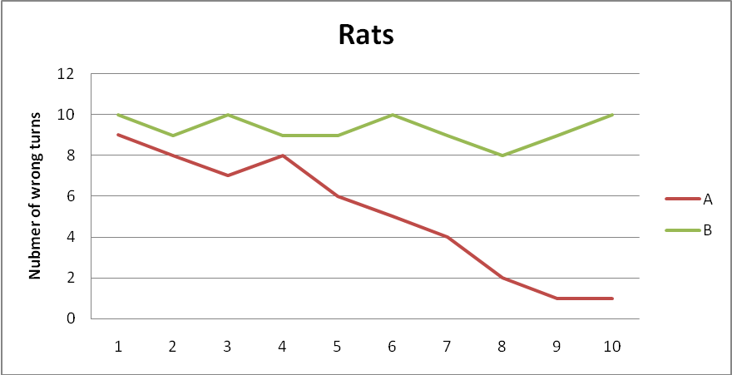

12/7/2009

Human body

kosti
collar bone – klíční kost
skull – lebka
jaw bone – celisti
tail bone – kostrc
ostatni jsou latinsky

organy
pancreas – slinivka
průdušky – pipes
spleen – slezina
intestine

12/14/2009

slovíčka:
outbreak: vypuknout
pathogen – škodlivý
eradicate – vymítit
gut – střeva
fungus – plísně
bacteria – pl. bakterie
lag/log/stationary/death phase – fáze vyvoje bakt.
germinate – klíčit
thread – svazek
rely upon – spoléhat se na
hijack – napadnout
burst – navýšit
faint – omdlýt
tissue – tkáň
swell – nateklý
sneeze – kýchnout
cough – kašlat
runny nose – teče z nosu..
handkerchief – kapesník
blow one's noes – vysmrkat se
crutch – berly
dandruff – lupy
louse – veš (pl: lice)
immune to sth: být imunní
scab – strup
antibody – protilátka
painkiller – prášky proti bolesti
immunological mamory – imunnologicka pamět
mould – plíseň
clinical trial – kl. zkouska
blind study/double-blind study – slepá studie (placebo apod)
puke/vomit/throw up – blejt

chicken pox – plané neštovice
small pox – pravé neštovice
measles – spalnicky
german measles – zardenky
tonsilitis – angina
rabies – vzteklina
jaundice – zloutenka
typhoid – tyfus
diphtheria – záškrt

1: chicken pox
2: influenza
3: common cold
4: influenza
5:jaundice
6: tonsilitis
7: -||-7
8: rabies
9: typhoid
10: -||-
11:measles
12: common cold
13:
14,15: small pox
16:

farins - hltan

12/21/2009

Idioms:
keep one's fingers crossed – držet někomu palce
keep an eye on… - dohlížet na někoho
give smbd a hand – pomoci
lift a fingere – pohnout (se), pomoci

1/4/2010
stand shoulder to shoulder – stát po boku

Diseases
clot – srážení
hemophilia – porucha srážlivosti krve
scarlet fever – spála

procariotic cell – simplier, doesnt have a nucleus, only DNA loop
eucariotic cell -

disenteria –
autitis – zanet str. ucha

amoeba – měnavka [ehmiiba]

Technologies
electric cattle/boiler – varná konvice

2010-04-12
1. After 148 days Dolly was born.
2. An unfertilized egg was taken from a Scottish black faced eve and it's nucleus was removed.
3. The cell started to divide producing a ball of cells after about six days.
4. A nucleus was removed from udder cell of Dolly's thindorset mother.
5. The udder cell nucleus was put into the unfertilized egg.
6. The ball of cells was then implanted into the uterus of another schotish black faced sheep.
7. She was geneticaly identical to her thindoreset mother.

2 4 5 3 6 1 7

